Exp.No-21
Sharpening Using Laplacian Mask with Extension of Diagonal Neighbors
Aim:
To sharpen an image using an extended Laplacian mask including diagonal neighbors.

Procedure:
- Start the program.
- Import the required libraries (cv2 and numpy).
- Read the input image (Virat.jpg).
- Define four source points on the image.
- Define four corresponding destination points.
- Calculate the Homography Matrix using cv2.findHomography().
- Apply the homography transformation using cv2.warpPerspective().
- Display the original and transformed images.
- Save the transformed image.
- Stop the program.
Program:
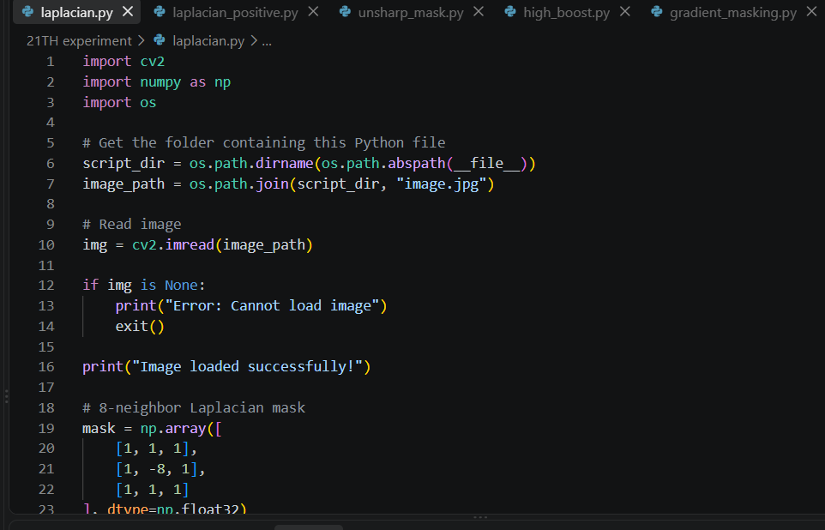
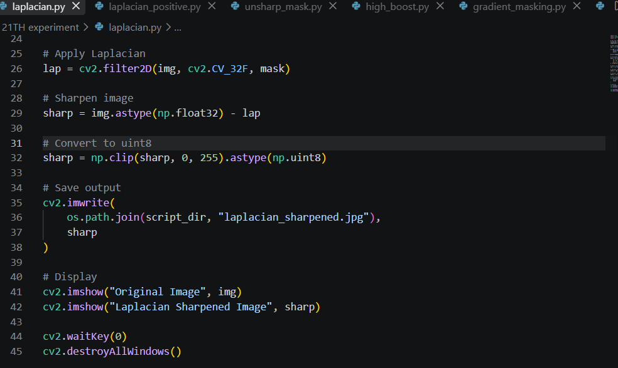
Input:
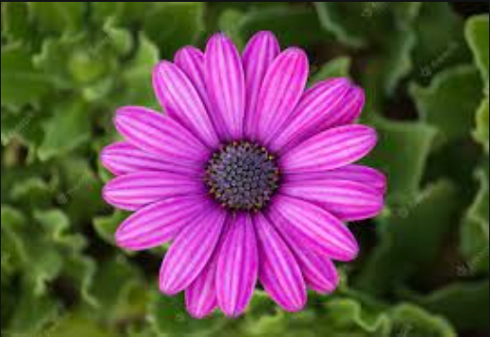

Output:
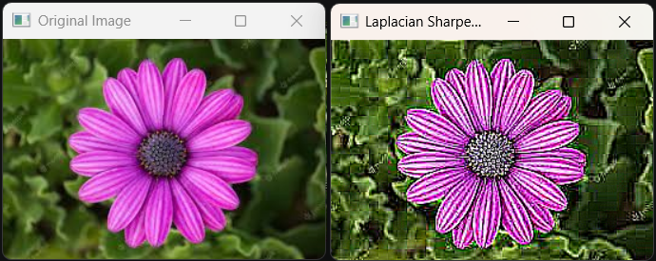

Result:
The image was successfully sharpened using the extended Laplacian mask.

